Data Flow Diagrams & User Stories
ShopEZ — MERN Stack E-commerce Application

Phase: Requirement Analysis Phase
TEAM ID : SWUID2026207177

Classification: Project Documentation — For Academic Submission
Data Flow Diagrams & User
Stories
1
. Introduction
This document presents the Data Flow Diagrams (DFDs) and formal User Stories for the ShopEZ platform. DFDs model the system at two abstraction levels — Context Level (Level 0) and Functional Decomposition (Level 1) — illustrating data flows between actors, processes, and data stores.
. Level 0 — Context Diagram
2
Login

Credentials
,
Search

Queries
,
Cart

Actions
,
Order

Details
Product

Catalogue
,
Cart

State
,
Order

Confirmations
Product

Data
,
Category

Data
,
Order

Status

Updates
Sales

Metrics
,
Order

Lists
,
Platform

Reports
Payment

Request
Payment

Success
/
Failure
Image

Upload

Request
Hosted

Image

URL
👤

Customer
🔑

Administrator
💳

Payment

Gateway
🖼

Cloudinary

CDN
🛒

ShopEZ

E
-
commerce

System
F
I
G
U
R
E

6
.
1

—

L
E
V
E
L

0
:

C
O
N
T
E
X
T

D
I
A
G
R
A
M

(
S
Y
S
T
E
M

A
S

B
L
A
C
K
B
O
X
)
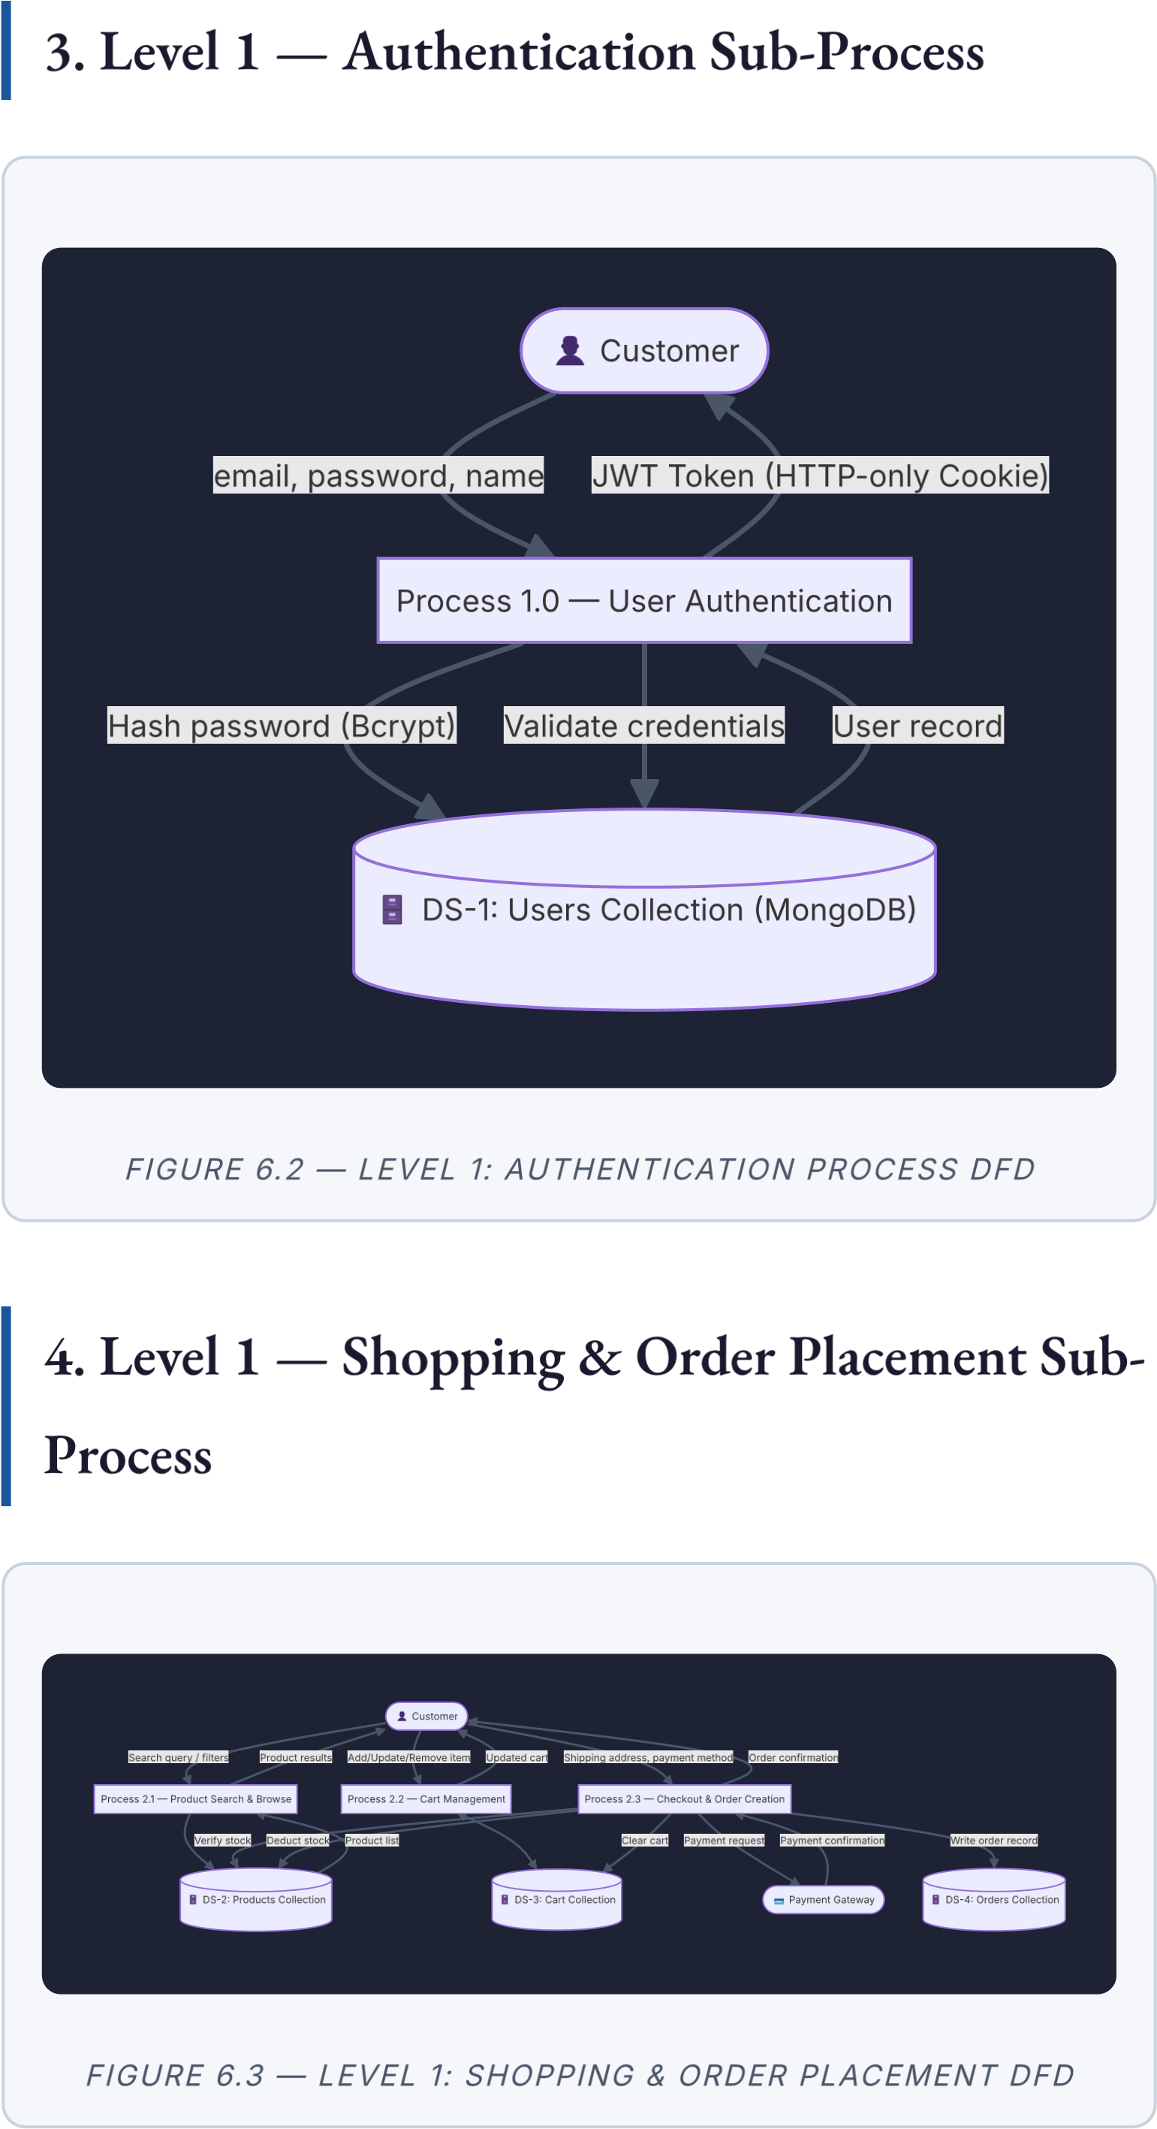
5. User Stories
USN |  | User  Type | User Story | Acceptance  Criteria | Points | Sprint
 | USN-  1 | Customer | As a customer, I can register by entering my name, email, and password. | Account created in DB; redirected to dashboard; duplicate email returns | 2 | Sprint  1
USN-  4 | Customer | As a customer, I can add, remove, and update  quantities in my cart. | Cart total updates in real time; cart persists across sessions and devices. | 3 | Sprint  2
400.
USN-  2 |  | Customer | As a customer, I can log in using my registered email and password. | JWT issued in HTTP-only cookie; incorrect credentials return 401. | 2 | Sprint  1
 | USN-  3 | Customer | As a customer, I can search and filter products by category, | Results accurately  reflect filters;  update  without full page reload. | 3 | Sprint  1
price, and rating.

USN | User  Type | User Story | Acceptance  Criteria | Points | Sprint
USN- Customer As a
5 customer, I
can complete a guided checkout by entering shipping and payment details.
All three 3 Sprint
checkout 2
steps navigable; address validated before proceeding.

USN-  6 |  | Customer |  | As a customer, I can securely pay via an integrated payment gateway. |  | Payment processed; order status changes to "Paid"; stock deducted; confirmation shown. |  | 5 |  | Sprint  2
USN-  7 | Customer |  | As a customer who has completed a purchase, I can leave a star rating |  | Review appears on the product page; aggregate rating recalculated. |  | 2 |  | Sprint  3
and review.
USN-  8 | Admin | As an admin, I can add, edit, and delete product  listings with  Cloudinary | Changes  reflect immediately on storefront; images served via CDN URL. | 3 | Sprint  1
USN | User  Type | User Story | Acceptance  Criteria | Points | Sprint
 |  | image uploads.
USN-  9 | Admin | As an admin, I can view all orders and update their delivery status. | Status transitions: Processing  → Shipped →  Delivered; reflected in customer's | 2 | Sprint  3
order history.
USN-  10 | Admin | As an admin, I can view aggregated sales metrics and monthly revenue charts. | Dashboard shows  accurate total revenue, order count, and monthly breakdown. | 3 | Sprint  3

ShopEZ MERN E-commerce Application · Requirement Analysis Phase · Data Flow
Diagrams & User Stories ·

